Aim of the work:
-The goal of this portfolio project is to design and build a database for storing and processing data related to the Airbnb use case.
-The database should make it easier to manage bookings, user profiles, accommodation details, ratings, and other pertinent information.
-The goal is to build a strong and efficient system that supports Airbnb's key functions and provides a seamless experience for both hosts and guests.
Methodology/Tools Used:
Entity Relationship Model (ERM):
-To develop the database for this project, I will use the entity-relationship modeling (ERM) methodology.
-ERM is a well-known and commonly applied method for envisioning and visualizing database structures.
-It aids in the identification of entities, their attributes, and the relationships between them, all of which are necessary for the development of an effective and scalable database system.
MySQL: In addition, I will implement and administer the database using a database management system (DBMS) such as MySQL.
Testing ideas for sustainability: What are positives and negatives?
Positives:
1. ERM represents the database schema in a clear and structured manner, making it easier to comprehend and maintain.
2. Using a database management system (DBMS) enables for efficient data storage, retrieval, and manipulation, resulting in optimal performance.
3. Storing and processing data through the platform allows for more efficient booking transactions and safe payment processing.
4. User profiles and ratings aid in the development of trust and accountability within the community.
Negatives:
1. It can take time and effort to design and develop a comprehensive database for a complex use case like Airbnb.
2. Data consistency and integrity need careful planning and validation across multiple entities and relationships.
3. Scaling the database to meet an increased user base and data volume may necessitate the usage of extra resources and optimization approaches.
Conception of the Project: Airbnb
(A) Requirements Specification for Airbnb Hotel Booking Use Case:
1. Roles
a. Guests: Airbnb users who want to book hotel rooms.
c. Hosts: Airbnb users who rent out their places as hotel rooms.
2. Actions
a. Guests can:
I. Look for available hotel rooms by location, dates, and other criteria.
II. View complete hotel room information, including amenities, photographs, and reviews.
III. They can leave feedback and ratings for their stays.
IV. Pay the amount for their booking by credit card to Airbnb.
V. Present themselves on Airbnb with a profile page.
VI. Communicate with the hosts through a phone call, etc.
b. Hosts are permitted to:
I. List their properties like hotel rooms, with extensive descriptions, photographs, and enter a phone number. Also, can create their Airbnb profile page.
II. Set their hotel room availability and pricing.
III. Communicate with guests about booking confirmations and other inquiries.
IV. Receive payments and track earnings (after 24 hours).
V. Use the platform’s calculator function to calculate the expected income with their own accommodation.
VI. Rate the User too.
3. Data and its Function
a. User profiles:
Data: Contains information about guests, hosts.
Function: User authentication and authorization.
b. Reviews and ratings:
Data: Captures feedback/ratings from guests about their stays and from the host also.
Function: To submit and store ratings/reviews for further development.
c. Connection to Social Media:
Data: Airbnb profile can be connected with social networks like Facebook.
Function: This enables the display of an Airbnb user's ratings through social contacts.
d. Accommodation:
Data: Includes details like location, amenities, availability, and pricing.
Function: To ensure proper and smooth research and filtering of hotel rooms.
e. Bookings:
Data: Records information about guests, hosts, dates, and payment transactions.
Function: To ensure smooth Booking management and payment processing.

(B) Entity Relationship Model (ERM)
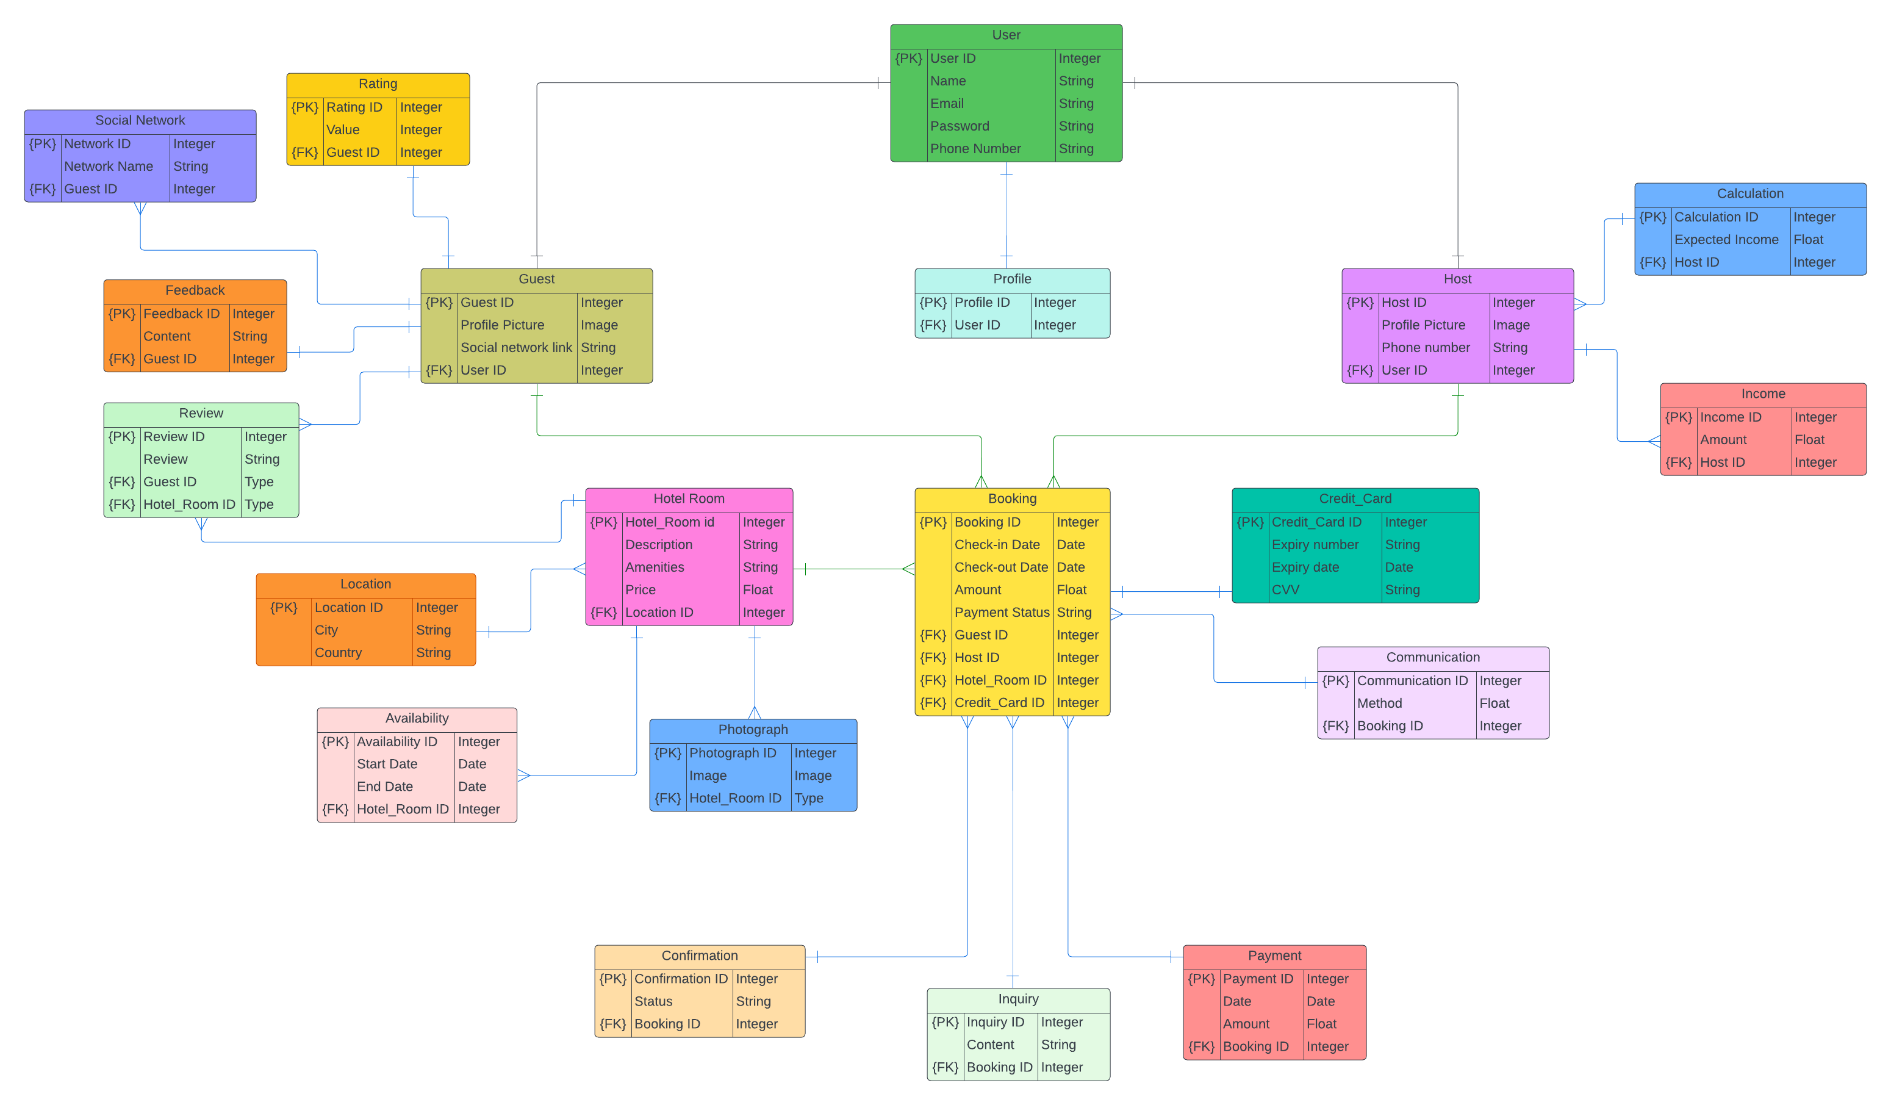

A. Explanation of the relationships between the entities:

User-Guest (1:1): One user can have one guest profile.
(User ID) is referenced as a foreign key in the Guest entity.
User-Host (1:1): One user can have one host profile.
(User ID) is referenced as a foreign key in the Host entity.
Guest-Booking (1:N):One guest can make multiple bookings.
(Guest ID) is referenced as a foreign key in the Booking entity.
Host-Booking (1:N): One host can have multiple bookings.
(Host ID) is referenced as a foreign key in the Booking entity.
Host-Income(1:N): A host can have multiple income records.
(Host ID) is referenced as a foreign key in the Income entity.
Booking-Hotel Room (N:1): Multiple bookings can be associated with a single hotel room.
(Room ID) is referenced as a foreign key in the Booking entity.
Hotel Room-Location (N:1): Multiple hotel rooms can be located in one location.
(Location ID) is referenced as a foreign key in the Hotel Room entity.
Booking-Credit Card (1:1): Each booking is associated with one credit card for payment.
(Card ID) is referenced as a foreign key in the Booking entity.
Guest-Review (1:N): One guest can leave multiple reviews.
(Guest ID) is referenced as a foreign key in the Review entity.
Hotel Room-Review (1:N): One hotel room can have multiple reviews.
(Room ID) is referenced as a foreign key in the Review entity.
Guest-Social Network (1:N): One guest can be associated with multiple social networks.
(Guest ID) is referenced as a foreign key in the Social Network entity.
Communication-Booking (1:N): One communication method can be associated with multiple bookings.
(Booking ID) is referenced as a foreign key in the Communication entity.
Calculation-Host (1:N): One calculation can be associated with multiple hosts.
(Host ID) is referenced as a foreign key in the Calculation entity.
Availability-Hotel Room (1:N): One hotel room can have multiple availability periods.
(Room ID) is referenced as a foreign key in the Availability entity.
Photograph-Hotel Room (1:N): One hotel room can have multiple photographs.
(Room ID) is referenced as a foreign key in the Photograph entity.
Profile-User (1:1): One profile is associated with one user.
(User ID) is referenced as a foreign key in the Profile entity.
Guest-Rating (1:1): A guest can give rating once.
(Guest ID) is referenced as a foreign key in the Rating entity.
Guest-Feedback (1:1): A guest can give Feedback once.
(Guest ID) is referenced as a foreign key in the Feedback entity.
Confirmation-Booking (1:N): One confirmation can be associated with multiple bookings.
(Booking ID) is referenced as a foreign key in the Confirmation entity.
Inquiry-Booking (1:N): One inquiry can be associated with multiple bookings.
(Booking ID) is referenced as a foreign key in the Inquiry entity.
Payment-Booking (1:N): One payment can be associated with multiple bookings.
(Booking ID) is referenced as a foreign key in the Payment entity.

B. Representation of the two triple relationships and their explanations:
1. Guest-Booking-Credit Card: It signifies that a guest can make a booking and provide their credit card details for payment purposes.
Guest-Booking: (1:N) relationship (a guest (1) can have multiple bookings (N))
Booking-Credit Card: (1:1) relationship (each booking (1) has a unique credit card (1))
2. Host-Booking-Hotel Room: It indicates that a host is associated with the booking of a specific hotel room.
Host-Booking: (1:N) relationship (one host(1) is associated with multiple bookings (N))
Booking-Hotel Room: (N:1) relationship (Multiple bookings(N) can be associated with a single hotel room (1))

C. For the cardinality notations: MARTIN Notation [Crow-Foot Notation]
Guest-Booking-Credit Card:
Guest-Booking: Cardinality: 1 to Many
Booking-Credit Card: Cardinality: One to One
Host-Booking-Hotel Room:
Host-Booking: Cardinality: one to Many
Booking-Hotel Room: Cardinality: Many to One
D. Data dictionary with a short description of the data attributes and their appropriate data types for all twenty entities:
Entity: User
User ID: Unique identifier for each user. (Data Type: Integer)
Name: Name of the user. (Data Type: String)
Email: Email address of the user. (Data Type: String)
Password: Password for user authentication. (Data Type: String)
Phone Number: Contact number of the user. (Data Type: String)
Entity: Guest
Guest ID: Unique identifier for each guest. (Data Type: Integer)
Profile Picture: Image representing the guest. (Data Type: Image)
Social Network Link: Link to the guest's social network profile. (Data Type: String)

Entity: Host
Host ID: Unique identifier for each host. (Data Type: Integer)
Profile Picture: Image representing the host. (Data Type: Image)
Phone Number: Contact number of the host. (Data Type: String)
Entity: Hotel Room
Room ID: Unique identifier for each hotel room. (Data Type: Integer)
Description: Description of the hotel room. (Data Type: String)
Amenities: List of amenities available in the hotel room. (Data Type: String)
Price: Price per night for the hotel room. (Data Type: Decimal or Float)
Entity: Location
Location ID: Unique identifier for each location. (Data Type: Integer)
City: Name of the city. (Data Type: String)
Country: Name of the country. (Data Type: String)
Entity: Booking
Booking ID: Unique identifier for each booking. (Data Type: Integer)
Check-in Date: Date of check-in for the booking. (Data Type: Date)
Check-out Date: Date of check-out for the booking. (Data Type: Date)
Amount: Amount paid for the booking. (Data Type: Decimal or Float)
Payment Status: Status of the payment. (Data Type: String)
Entity: Credit Card
Card ID: Unique identifier for each credit card. (Data Type: Integer)
Card Number: Credit card number. (Data Type: String)
Expiry Date: Expiration date of the credit card. (Data Type: Date)
CVV: CVV code of the credit card. (Data Type: String)
Entity: Review
Review ID: Unique identifier for each review. (Data Type: Integer)
Rating: Rating given for a hotel room. (Data Type: Integer)
Review: comments provided as review of the stay. (Data Type: String)
Entity: Social Network
Network ID: Unique identifier for each social network. (Data Type: Integer)
Network Name: Name of the social network. (Data Type: String)
Entity: Communication
Communication ID: Unique identifier for each communication. (Data Type: Integer)
Method: Method used for communication (e.g., Phone Call). (Data Type: String)
Entity: Calculation
Calculation ID: Unique identifier for each calculation. (Data Type: Integer)
Expected Income: Expected income calculated for a host's accommodation. (Data Type: Decimal or Float)
Entity: Availability
Availability ID: Unique identifier for each availability. (Data Type: Integer)
Start Date: Start date of the availability period. (Data Type: Date)
End Date: End date of the availability period. (Data Type: Date)
Entity: Photograph
Photograph ID: Unique identifier for each photograph. (Data Type: Integer)
Image: Image file representing a photograph. (Data Type: Image)
Entity: Profile
Profile ID: Unique identifier for each profile. (Data Type: Integer)
User ID: Identifier linking a profile to a user. (Data Type: Integer)
Entity: Rating
Rating ID: Unique identifier for each rating. (Data Type: Integer)
Value: Value representing a rating(Out of 5). (Data Type: Integer)
Entity: Feedback
Feedback ID: Unique identifier for each feedback. (Data Type: Integer)
Content: comments provided as feedback to suggest suitable changes. (Data Type: String)
Entity: Confirmation
Confirmation ID: Unique identifier for each confirmation. (Data Type: Integer)
Status: Status of the confirmation. (Data Type: String)
Entity: Inquiry
Inquiry ID: Unique identifier for each inquiry. (Data Type: Integer)
Content: Content or comments provided in the inquiry. (Data Type: String)
Entity: Payment
Payment ID: Unique identifier for each payment. (Data Type: Integer)
Date: Date of the payment. (Data Type: Date)
Amount: Amount of the payment. (Data Type: Decimal or Float)
Entity: Income
Income ID: Unique identifier for each income record. (Data Type: Integer)
Amount: Amount of income earned. (Data Type: Decimal or Float)

Abstract of my work:
This project focuses on creating the "Airbnb" online platform, which makes it easier to rent out rooms and book hotels.
The goal is to offer a central location where visitors can quickly look for available accommodation, view comprehensive information, make bookings, and get in touch with hosts.
The platform offers features like social network integration and host income calculation in addition to ensuring secure payments and allowing users to rate and submit feedback.
By offering an effective and user-friendly platform for both guests and hosts, the solution solves
the issue of the inefficiency and inconvenience in traditional booking methods that is now present.
Working Steps:
Requirements obtaining: The initial phase is to meet the requirements for Airbnb platform, like knowing the functions and features that are required, as well as the roles that visitors and hosts play and how they interact.
Entity Identification: The system's constituent entities are identified based on the requirements.
Specification of Attributes: The suitable attributes for each entity are identified. To uniquely identify each instance of an entity, key attributes are identified.
Relationship Establishment: The relationships between the entities are established based on their actions and interactions.
ER Model Creation: Using the identified entities, attributes, and relationships, an Entity-Relationship (ER) model is created.
Data Dictionary: A data dictionary is created to provide a short description of each attribute, including its data type and purpose.
Problem Description: The prevailing challenge of unpleasant and inefficient hotel booking procedures is described. The development of the Airbnb platform is one of the strategies suggested as a potential solution to these issues.
Existing Issue:
Because Traditional ways of making hotel bookings frequently lack ease and transparency, making the process difficult for both guests and hosts, an effective and user-friendly platform is required for hotel reservations and rental services.
Solution Approaches:
The development of an online platform named "Airbnb" that acts as a link between guests and hosts and offers a smooth booking experience is the proposed answer to the issue at hand. A variety of features and functionalities are available on the platform to improve the user experience overall.
1. Centralized Booking System: The platform serves as a middleman, enabling visitors to look for open hotel rooms using various filters, including location, dates, and other details. Each hotel room's detailed information, including amenities, pictures, and reviews, is available to visitors. They can then use the platform directly to make bookings.
2. User profiles: On the platform, each user—whether a guest or a host—can build a profile. While hosts post images, describe their rooms, and establish availability and pricing, guests supply the essential information.
3. Secure Payment System: Credit cards are accepted as a safe form of payment by guests. The technology makes sure the transaction goes through without a hitch and that hosts get paid 24 hours after the guest checks in, guaranteeing the guest will find their accommodation exactly as described.
4. System for Rating and Feedback: Both visitors and hosts are able to rate and remark on their respective experiences.
5. Social Network Integration: Users can connect their profiles to social networks like Facebook using the social network integration feature. Through this integration, evaluations and comments from social contacts can be displayed, further increasing transparency and authority.
6. Income Calculation: Based on the information about their accommodations, hosts can use the calculator function on the platform to forecast their anticipated income.

